**Production of the piece**

I have added an empty project to start.

My USB Alesis Q49 keyboard is plugged in and I am getting an input signal every time I press the keys.

I have set the time signature to 4/4 and I have also set the tempo to 90bpm. I did this by accessing the tempo track feature in Cubase.

Right mouse clicking in the instrument panel is where I have added instrument and audio tracks. Once I have selected the instrument track I have chose Halion as a VST, Selected Q49 for the MIDI input (which is my USB keyboard) and made sure the outputs are also set. I have names the track Organ and then clicked add track.

I searched up organ in the sounds search. There was a good number to choose from but I selected progressive organ as this one sounded most like the organ used in three little birds by Bob Marley.

I then configured the instrument settings to make the organ unique. I did this by increasing the rotary rate to maximum reduce the resonance and increase the cut off and attack. I just played one note over and over again until I liked the sound. I then saved this as my preset.

Auto quantise is on to keep everything in time

Quantise set to 1/8

Metronome turned on and a 4 count in enabled for when I press record.

All of my chords have been recorded into the organ track. The timing is perfect thanks to AQ and it didn’t take long at all.

Section B chords have also been recorded without the off-beat



I have coloured my song into sections A and section B and used duplicate to get the sections together. The snap feature is also activated to make sure all notes and blocks all snap into place with the 1/8 quantise.

The drums were the next part that I created. By using the same process and finding the right drum sound. I decided on standard room kit sound and then changed the channel to channel 10 and the map to a GM map this meant that I could work in drum hits instead of keyboard pitches.

I have written the first drum section A. It has a four on the floor kick drum and an off-beat hi hat. Having the project set up in 1/8 made writing this really easy.

The section B has a drop beat. This was easy to compose as I duplicated the first section and dropped the 1st beat to the second.

I wrote my bassline by using a mixture of the traid notes from the chords and the notes from the D major scale. I spent no more than 15 minutes doing this and then settled on a bassline that had short notes and was a repeated riff. By using auto quantise I was able to get every note in time. The velocity of the bass track is uneven where I was pressing down differently on the keyboard. At first I thought I will correct this in task four but I actually want to leave it because it is more natural to a real life player.

This is the audio track that I created. It is a mono track because there is only one guitar input so there’s no need for it to be stereo. I set the amp and the guitar up in the practice room and got a sound that I was happy with. I had the Cubase file open with the metronome on so Sir could just sit down and play. I spoke with him and sang the type of thing that I wanted him to play. He asked if I wanted it palm muted or open and I said palm muted which is a technique reggae guitarists used for the section A and then the off-beat open for the section B. H took three goes and I kept the second one.

Trumpet pt1

Trumpet pt2

The same process was used as I did with the bass line. I wanted to get something catchy and something that didn’t use too many notes. I pitched it higher than everything else so it sat on the top of everything. I just played around with idea on loop and my fingers in place of the scale. I recorded three ideas and kept the last one. I then duplicated it and raised the pitch of the second track and made it a different instrument called a trombone.

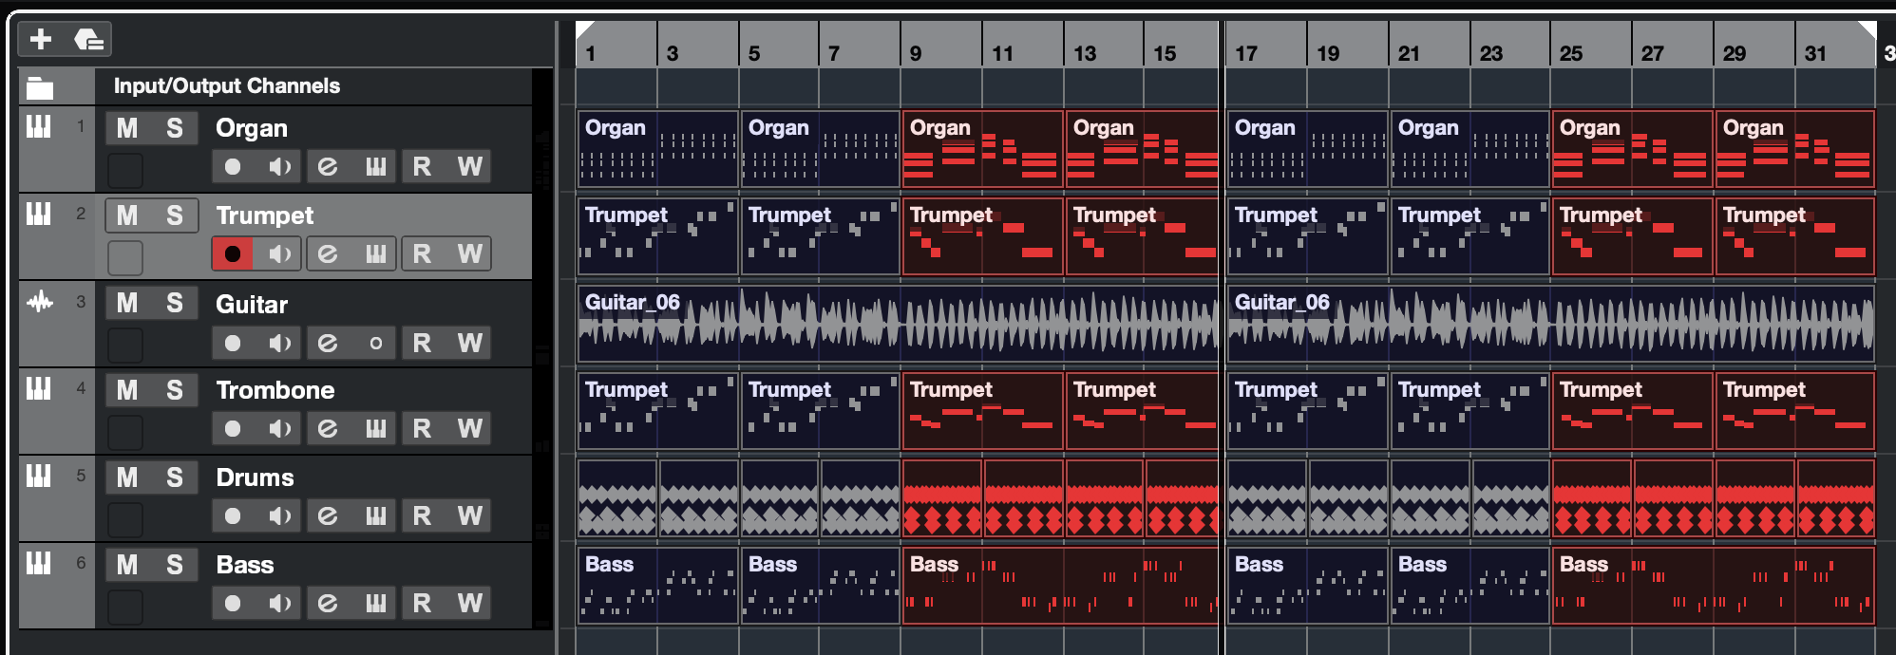

This is my final task 3 with all of my tracks in. To export I clicked Control and A and the pressed P so it knew to select only the parts of my song that I wanted to be exported.

File – Export – Audio mixdown. I selected WAVE as the file format for the best quality and made sure the sample rate was 44.100

**Evaluation**

Positives:

* I stuck to my plan in task 2
* My piece sounds like it’s in the style of reggae because the instrument sounds are really good. On first listening I wouldn’t be able to tel tell if they were real or not.
* My use of Cubase is excellent. I have used so many tools in Cubase really easily to get a really good sounding song.

Negatives:

* Actual recording of real drums and real drummer would have enhanced the quality of the drums. Mine are obviously fake due to the equal volume of everything.
* The whole project is major in tonality it sounds really cheesy which I’m a bit disappointed in. If I were to re record the project I would include a minor chord or maybe add a 7th chord.